
Rockingham County
2012 Community Health Assessment Executive Summary

Social Determinants —Edu cation




Ac cess to H ealth Ca re

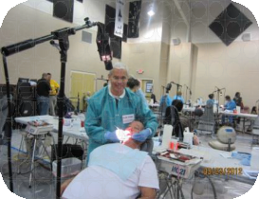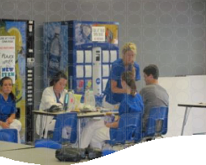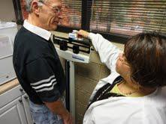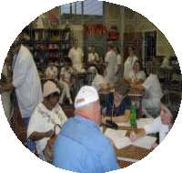

Nu trition and Physica l Ac tivit y

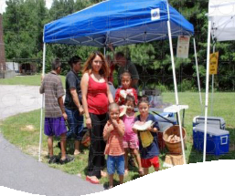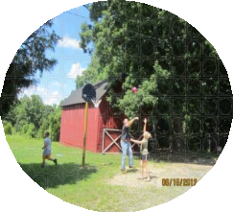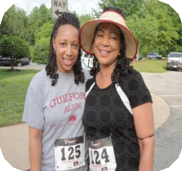

Prioritizing Community Health
For Today, Tomorrow, and Future Generations

Table of Contents
Ro

Community Health Assessment Overview ………………………….........…………………………….. 2 Community Health Assessment Method ………………………….…….............…………………….. 2 About Rockingham County ……………………………………………………..............………………… 4
Community Health Assessment Data Summary ………………………………………................…… 9
Social Determinants …………………………………...……………………….........…….…. 11
Poverty …………….……………………………………………………........….……. 11
Education ………….…………….…………………………………………........………. 12
Tobacco Use …………….….......………………………………………………………….. 15 Violence ……………………........……………………………………………...………...… 15 Access to Healthcare ………...............…….....…………………………………………......…... 16 Services to the Elderly 18
Oral Health 19
Substance Abuse and Mental Health 19
Nutrition and Physical Activity 20
Diabetes 22
Obesity 22
Heart Disease 23
Other 24
Cancer 24
Maternal and Child Health 24
Unintentional Injury 26
United Way of Rockingham County 27
Epilogue …………………...........................……………………………….………………………………. 29

Community Health Assessment Overview

Ro
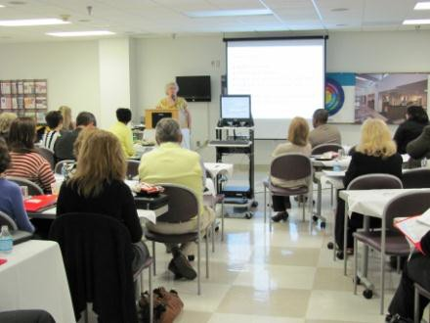In December 2010, the Rockingham County Department of Public Health, Rockingham County Healthy Carolinians Partnership, and the United Way of Rockingham County began the 2012 Community Health Assessment (CHA) process. The Community Health Assessment is the foundation for improving and promoting the health of community members and is conducted every four years to meet requirements for state accreditation of local health departments. The charge of the CHA is to identify factors that affect the health of a population and determine
the availability of resources within the community to adequately address those factors.

From 2010 to 2012 there was significant collaboration with community leaders, public health agencies, businesses, hospitals, academic and faith communities, and other service providers to assess the strengths and areas of need in the county. In addition to assessing and understanding the community’s health status, the CHA serves as a blueprint which guides the Health Department in strategic planning, as well as the Healthy Carolinians Partnership and community partners in their efforts to address the top health concerns of the citizens of Rockingham County. The assessment criteria are as follows:

- Identify priority health issues
- Identify priority health populations
- Identify community resources
- Develop a community-based action plan to address the identified concerns
- Report the results to residents, community agencies, and community stakeholders

The Rockingham County Healthy Carolinians Partnership organizes community partners through local workgroups, which focus on addressing the top health priorities identified through the 2012 Community Health Assessment process. The ultimate goal is to achieve the Healthy North Carolina 2020/Healthy People 2020 health objectives.

Data Collection Methodology

Local data collection consisted of conducting community-wide surveys, hosting focus groups among target populations, and retrieving data from a variety of reputable sources, including the North Carolina State Center for Health Statistics, the United States Census Bureau, Rockingham County Department of Public Health, and other local entities, for comparison with state data.

About Rockingham County

(this county spends a long time on community profile and SDOH)

Rockingham County, formed from the northern half of Guilford County on December 29, 1785, is the epitome of rural country living. Dubbed North Carolina’s North Star, Rockingham County is located in the middle of the state at the tip of the Piedmont Triad region, and is cradled by the foothills of the Blue Ridge Mountains. Rockingham County is conveniently located just hours away from the best attractions North Carolina has to offer – the mountains to the west and the beaches to the east.

Rockingham County Population Profile

Rockingham County Profile Today
County Size | 572 square miles
County Population | 93,643
County Workforce | 44,960
County Tax Rate | $0.6960 per $100 valuation
County Seat | Wentworth

The county has six municipalities: the cities of Eden and Reidsville and the towns of Madison, Mayodan, Stoneville, and Wentworth. While North Carolina’s population grew approximately 16.6% from April 1, 2000 to July 1, 2009, Rockingham County’s population grew 0.3%. Rockingham County has an aging population with approximately 16.0% of its residents 65 years and older in comparison to 12.7% for the state of North Carolina. The majority of Rockingham County’s citizens are white (73.4%) while 18.9% are Black according to the 2010 U.S. Census. Persons who are Native Hawaiian (0.1%), American Indian (0.4%), Asian (0.5%), Other Race (2.8%), and Hispanic (5.5%) represent additional population estimates.

Population Profile, 2010
Rockingham County
North Carolina
80
60
40
20
0
73.4
65.3
18.9 21.5
5.5
8.4
0.5 2.2
0.4 1.3
0.1 0.1
White
African
American
Hispanic
Asian
American Indian Native Hawaiian

Rockingham County Population by Municipality, 2000 – 2010

Ro
Municipality | 2010  Population | 2006  Population | 2000  Population | % Change 2000 - 2006 | % Change 2006 - 2010 | % Change 2000 - 2010
Rockingham County | 93,643 | 93,063 | 91,928 | 1.2% | 0.6% | 1.9%
Eden | 15,527 | 15,643 | 15,908 | -1.7% | -0.7% | -2.4%
Madison | 2,246 | 2,287 | 2,262 | 1.1% | -1.8% | -0.7%
Mayodan | 2,478 | 2,610 | 2,417 | 8.0% | -5.3% | 0.3%
Reidsville | 14,520 | 14,859 | 14,485 | 2.6% | -2.3% | 0.2%
Stoneville | 1,056 | 989 | 1,002 | -1.3% | 6.3% | 5%
Wentworth | 2,807 | 2,786 | 2,779 | 0.3% | 0.8% | 1.0%

In Rockingham County, the estimated median age was 39 in 2000, 42 in 2010, and is estimated to be 43 in 2015 (rounded number of age). Estimated population by age is as follows:

Rockingham County Population by Age, 2010
Age Range | Total Population | Percentage of Population
0 – 19 | 22,689 | 24.5%
20 - 29 | 9,758 | 10.5%
30 - 39 | 11,745 | 12.7%
40 - 49 | 13,800 | 14.9%
50 - 59 | 14, 005 | 15.1%
60 + | 20,561 | 22.2%

Households and Social Determinants of Health

According to the 2010 U.S. Census Bureau, there were 38,693 households in Rockingham County. This is an increase of 1,693 (4.4%) households since 2006. The members of households owned with a mortgage or loan was 16,871 (43.6%), owned free and clear 10,149 (26.2%), and renter-occupied 11,673 (30.2%).


Rockingham County Household Type
Household Type | Number | Percent
Total Households | 38,693 | 100%
Family Households [1] | 26,168 | 67.6%
Male Householder | 17,728 | 45.8%
Female Householder | 8,440 | 21.8%
Nonfamily Households [2] | 12,525 | 32.4%
Male Householder | 5,652 | 14.6%
Living Alone | 4,725 | 12.2%
Female Householder | 6,873 | 17.8%
Living Alone | 6,166 | 15.9%

[1] A household that has at least one member of the household related to the householder by birth, marriage, or adoption is a “Family household.” Same-sex couple households are included in the family households category if there is at least one additional person related to the householder by birth or adoption. Same- sex couple households with no relatives of the householder present are tabulated in nonfamily households. [2] “Nonfamily households” consist of people living alone and households which do not have any members related to the householder.

Median Household Income of Peer Counties
Counties | 2000  Median Household Income | 2011  Median Household Income | 2016  Median Household Income | 2000  Per Capita Income | 2011  Per Capita Income | 2016  Per Capita Income
North Carolina | $39,190 | $42,941 | $51,200 | $20,307 | $23,955 | $26,700
Rockingham County | $33,915 | $35,814 | $42,336 | $17,120 | $19,939 | $22,558
Burke County | $35,582 | $36,883 | $43,816 | $17,397 | $19,972 | $22,227
Caldwell County | $35,724 | $36,936 | $44,553 | $17,353 | $19,632 | $21,915
Lee County | $39,160 | $41,552 | $48,031 | $19,147 | $21,755 | $23,734
Surry County | $33,224 | $35,453 | $40,053 | $17,722 | $19,649 | $21,704
Wilkes County | $34,214 | $36,062 | $40,927 | $17,516 | $19,873 | $21,812

Ro
Top 10 Employers | Number of Employees
Rockingham County Schools | 2071
Morehead Memorial Hospital | 1000
Unifi, Inc. | 892
Wal-Mart Associates, Inc. | 807
Rockingham County Government | 650
Miller-Coors | 600
Moses H. Cone Hospital (Annie Penn) | 600
Frontier Spinning Mills | 515
Keystone Foods | 423
 | 420

Unadjusted Unemployment Rate, August 2012
 | Unemployment Rate
United States | 8.2%
North Carolina | 9.6%
Rockingham County | 10.7%

Unemployment in Rockingham County has been persistent and has not been less than 10.7% since January 2009. Over 22% of the jobs in the county are in manufacturing, compared to just over 11% in North Carolina. The 2012 Community Assessment Survey reveals that 13% of respondents work in industry related jobs and 7% were unemployed.The economic base of the county was largely built around textiles, tobacco, and furniture. During the years of growth and prosperity of the textile and tobacco industry, Rockingham County was an economically thriving county. After the loss of thousands of textile and tobacco jobs, Rockingham County is now ranked as a Tier 1 county in North Carolina. The educational level and job readiness of the citizens continue to be problematic as the county transitions away from a textile- and tobacco-based economy. The county’s strong ties to tobacco and its weak economy have contributed to poor health behaviors among its citizens. Research continues to show the link between the health status of a population and its economic status. The county has recognized this link and is actively working to improve the educational attainment and job readiness of its citizens. Rockingham County is fortunate to have strong community partners and stakeholders that are exceptional in their ability to work collectively on the problems and issues facing the county.coun

Poverty
Rockingham County rates very close to North Carolina when comparing poverty rates. Rockingham County has a slightly higher elderly poverty rate and percentage of people receiving food assistance at 12% and 15%, respectively (11% and 14% for North Carolina), a higher poverty rate at 19% (17% for NC), and a higher child poverty rate at 27% (25% for NC). Fourteen percent of residents who completed the 2012 Community Assessment Survey were receiving public assistance.
Rockingham County vs North Carolina
Poverty Rates Based on Race and Specific Populations, 2010
60%
50%
40%
30%
20%
10%
0%
27%
19%
17%
25%
Poverty Child
Rate Poverty Rate*
12%
11%
Elderly Poverty Rate
15%
14%
Percent Receiving Food Assistance
Rockingham County
North Carolina
*Child Poverty Rate based on 2006-2010 data.

The N.C. Department of Commerce (NCDOC) ranks Rockingham County as one of 40 most distressed counties in the state based on economic well-being, labeling the county as a Tier 1 county.

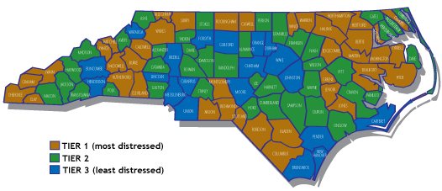

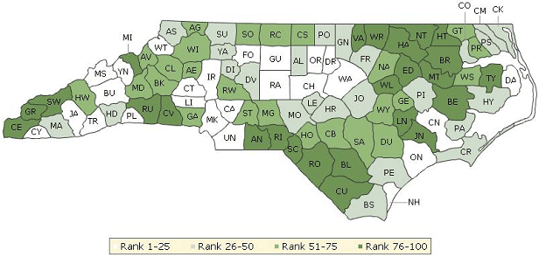
The 2012 County Health Rankings revealed Rockingham County ranks 78 out of 100 counties in Health Outcomes (mortality – length of life and morbidity – quality of life), with 100 being the least healthy county.

Ro

How much income or wealth a person or population has can contribute to overall health status. For example, higher income and greater wealth make it easier to pay for insurance premiums, deductibles, copayments and medicines, which can be particularly important when people become ill. Perhaps more importantly, greater economic resources also increase people’s access to conditions that help prevent illness in the first place, enabling them to eat more nutritious food, stay physically active, and live in safe homes and neighborhoods. Conversely, limited economic resources can mean serious obstacles to good health, limiting a person’s opportunities—and sometimes motivation—to adopt healthier behaviors.

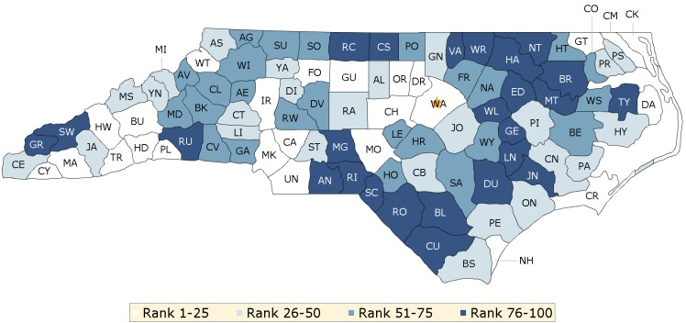

The 2012 County Health Rankings revealed Rockingham County ranks 90 out of 100 counties in Health Factors (social and economic factors, health behaviors, and clinical care), with 100 being the least healthy county.

Education


Drs. Johnson and Parnell, authors of the Rockingham County Competitiveness Assessment, observed that “while Rockingham County has a willing work force, there is a significant mismatch between their skills and the ones required by most businesses today.” Business leaders told their researchers that the transition from old-line textile or tobacco jobs to employment in 21st century advanced manufacturing is made difficult by the old culture of manufacturing. For decades, residents could leave school and go straight to work in a factory where pay was reasonably good. Education had no obvious economic value.

Despite recent improvement, education remains a major weakness. In 2010, although Rockingham County reported a higher estimated percentage than that of the state of residents 25 years of age and older who were high school graduates (34.4% and 27.7%, respectively), the county had much lower percentages of residents who went on to graduate high school and obtain their associate’s degree, bachelor’s degree, or graduate/professional degree. Only 69% of Rockingham County residents over age 25 have at least a high school degree, compared to the state rate of 78%. Only 11% have a bachelor’s degree, compared to 22.5% of North Carolina residents.

Low educational attainment limits the possibility of attracting better paying advanced manufacturing, high tech, or bio tech jobs. Residents with less education will not be as well informed about health care issues such as exercise, nutrition, tobacco cessation, alcohol moderation, and regular health and dental examinations.

From 2008 to 2010, the number of high school graduates has remained fairly consistent compared to previous years in Rockingham County, at 33.9%. The Community Assessment Survey revealed a similar level of education for residents who responded to the survey. When compared to peer counties, Rockingham County has a higher percentage of individuals with some college and a high school diploma, at 23.6% and 33.9%, respectively.

Ro

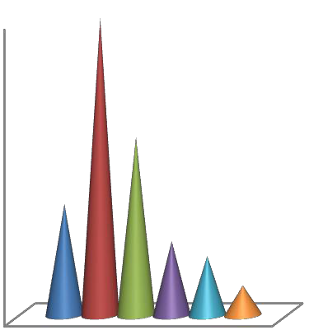
Rockingham County Educational
Attainment Population 25 Years and Over, 2008 - 2010
2.5%
10.3% 13.7%
7.0%
9th to 12th Grade, No
Diploma
High School Graduate (Includes Equivalency) Some College, No Degree
23.6%
33.9%
Associate's Degree

Bachelor's Degree
Graduate or Professional
Degree
Highest Level of Schooling
Completed by Survey Respondents
40%
40%
35%
30%
25%
20%
15%
10%
5%
0%
24%
Less than High
School Degree
High School Graduate or GED
Some College
15%
Associate Degree
10%8%
4%
Four-Year Degree
(Bachelor's)
Advanced Degree (Master's, PhD)

Peer County Educational Attainment 2008 – 2010 Population 24 Years and Over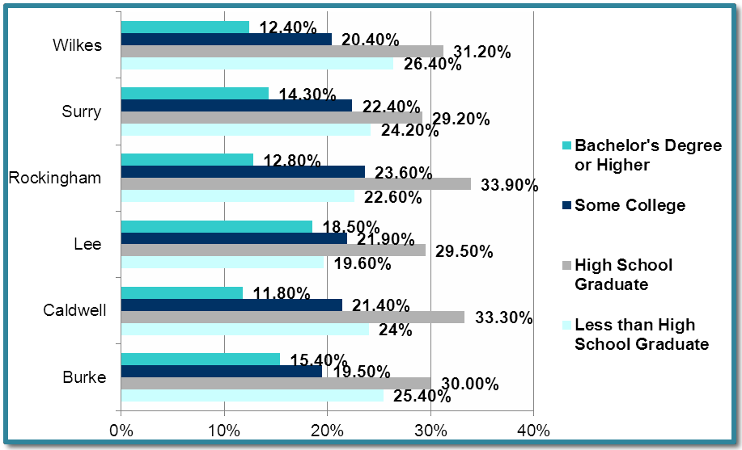

The four-year cohort graduation rate increased by 3.6% in the 2011 – 2012 school year from the previous year. On the other hand, the dropout rate in Rockingham County is significantly higher than that of North Carolina, at 4.58 and 3.43, respectively in the 2010/2011 school year. When examining SAT performance, Rockingham County Schools have seen an overall decrease in SAT scores since 2008 in the areas of critical reading, math, and writing.

Rockingham County Four-Year Cohort North Carolina Four-Year Cohort Graduation Rate, 2008-2012 Graduation Rate, 2008-2010

Ro


82.0%

80.0%
78.0%

76.0%
74.0%

72.0%
70.0%

68.0%
66.0%

64.0%
2008
2009
2010
2011
2012
78.0%
76.0%
76.0%

74.0%
72.9%
72.4%
72.0%

70.0%
69.0%
68.0%

66.0%

64.0%
2008 - 2009 2009 - 2010 2010 - 2011 2011 - 2012

High School Dropout Rates, 2006 – 2011

7
6
5
4
3
2
1
0
6.01
6.39
5.15
5.27
4.97
4.78

4.27
4.58
Rockingham
County
3.75
3.43
North
Carolina
2006-2007 2007-2008 2008-2009 2009-2010 2010-2011

SAT Performance by Students in North Carolina’s School Systems and Schools

 | Critical Readi |  | ng |  | Math |  | Writing |  |  |  | Total
2008 | 480 | 496 |  | 492 |  | 511 | 461 |  | 482 | 1433 |  | 1489
2009 | 464 | 495 |  | 488 |  | 511 | 457 |  | 480 | 1409 |  | 1486
2010 | 472 | 497 |  | 494 |  | 511 | 457 |  | 477 | 1423 |  | 1485
2011 | 479 | 493 |  | 487 |  | 508 | 456 |  | 474 | 1414 |  | 1475
Rockingham County |  | North Carolina |  | Rockingham County |  | North Carolina | Rockingham County | North Carolina |  | Rockingham County |  | North Carolina

(they did a great job with Social Determinants of Health, but did not include a Health Ranking summary table, below is an example of one from another county)

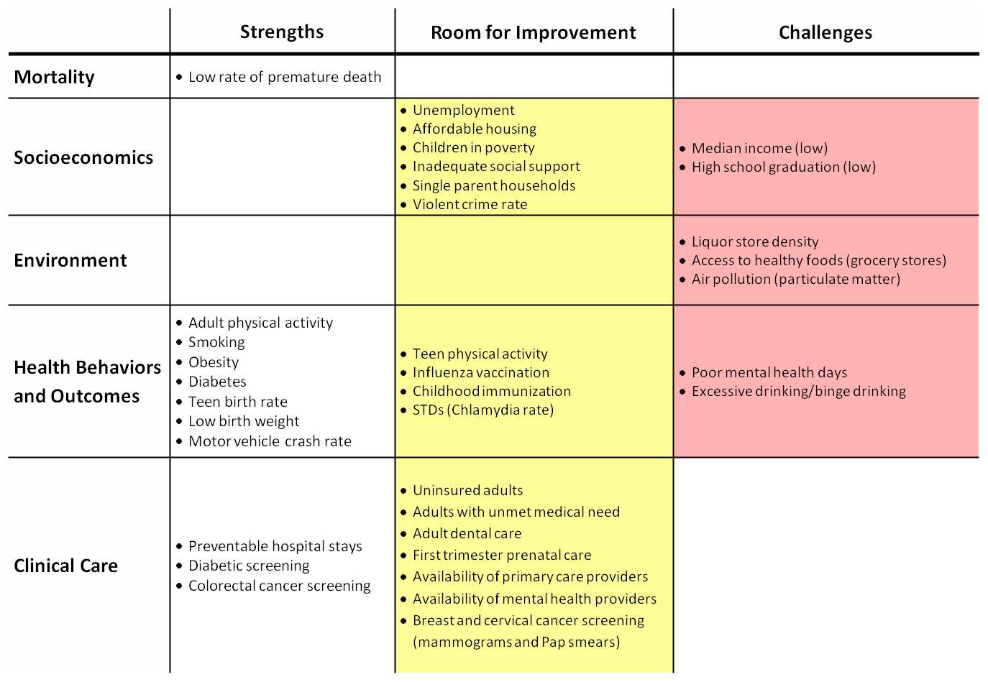
- Leading Causes of Death

Ro
The leading cause of death in Rockingham County changed from 2009 to 2010. There were more individuals who died from cancer (227) in 2010 than diseases of the heart (219). The age-adjusted (used to better allow populations to be compared when the age profiles of the populations are quite different) death rate for Rockingham County from 2006-2010 was higher in diseases of the heart (208.8) than cancer in all sites (203.2). Rockingham County has a higher age-adjusted death rate than North Carolina in both cancer and diseases of the heart.

 | 2010 |  | 2009
Cause of Death | Total Number | Rank | Total Number | Rank
Cancer | 227 | 1 | 229 | 2
Diseases of heart | 219 | 2 | 255 | 1
Chronic lower respiratory diseases | 83 | 3 | 91 | 3
Cerebrovascular diseases | 65 | 4 | 74 | 4
All other unintentional injuries | 31 | 5 | 36 | 5
Influenza and pneumonia | 30 | 6 | 34 | 6
Diabetes mellitus | 28 | 7-8 | 27 | 7
Nephritis, nephrotic syndrome and nephrosis | 28 | 7-8 | 18 | 10
Essential (primary) hypertension and hypertensive renal disease | 25 | 9 | * | **
Alzheimer's disease | 20 | 10 | 19 | 9
Motor vehicle injuries | 9 | ** | 25 | 8
All other causes (residual) | 267 | N/A | 241 | N/A
Total Deaths -- All Causes | 1023 | N/A | 1049 | N/A
- Data not available
** Does not rank in top 10 causes of death

Leading Causes of Death in Rockingham County compared to Peer Counties: Age-Adjusted Death Rate per 100,000 Population, 2006-2010
Leading Cause of Death |  | Rockingham County | Burke County | Caldwell County | Lee County | Surry County | Wilkes County | North Carolina
Heart Disease |  | 208.8 | 196.5 | 203.1 | 187.1 | 200.2 | 175.0 | 184.9
Cancer-all sites |  | 203.2 | 189.3 | 205.8 | 159.0 | 199.8 | 184.5 | 183.1
Chronic Lower Respiratory Disease |  | 71.7 | 53.4 | 67.2 | 44.6 | 60.8 | 53.6 | 46.4
Trachea, Bronchus, and Lung  Cancer |  | 67.6 | 62.0 | 73.5 | 54.8 | 67.4 | 59.5 | 55.9
Cerebrovascular Disease |  | 56.8 | 45.7 | 53.5 | 45.5 | 51.1 | 49.3 | 47.8
All Other Unintentional Injuries |  | 38.5 | 43.2 | 37.1 | 27.5 | 40.9 | 54.1 | 28.6
Pneumonia and Influenza |  | 29.3 | 21.0 | 20.4 | 13.2 | 21.4 | 25.5 | 18.5
Breast Cancer |  | 27.3 | 25.3 | 22.8 | 19.6 | 23.3 | 12.9 | 23.4
Diabetes Mellitus |  | 26.6 | 21.6 | 24.4 | 24.5 | 19.3 | 23.2 | 22.5
Motor Vehicle Injuries |  | 25.5 | 16.4 | 17.5 | 25.6 | 20.3 | 27.8 | 16.7
Nephritis, Nepthrotic Syndrome, and Nephrosis |  | 20.0 | 20.6 | 21.0 | 13.7 | 19.2 | 12.5 | 18.9
Colon, Rectum, and Anus Cancer |  | 17.8 | 19.3 | 16.8 | 15.2 | 18.4 | 14.6 | 16.0
Septicemia |  | 17.0 | 15.2 | 12.6 | 11.4 | 16.4 | 16.6 | 184.9
Suicide |  | 13.3 | 16.3 | 16.0 | 9.1 | 14.9 | 17.4 | 183.1
Chronic Liver Disease and Cirrhosis |  | 12.4 | 10.2 | 10.6 | 11.5 | 11.1 | 10.3 | 46.4

Rockingham County and North Carolina’s Leading Causes of Death for Residents Race-Specific and Sex-Specific Age-Adjusted Death Rates (Rates per 100,000), 2006-2010

Ro
Leading Cause of Death |  | Rockingham County  White African Male Female American |  |  |  | North Carolina  White African Male Female American
 |  |  |  |  |  |  | 180.7 219.8 237.2 145.8
Diseases of Heart |  | 207.0 228.4 |  | 274.1 | 162.9
Cerebrovascular Disease |  | 52.5 | 80.5 |  |  |  | 44.6 | 65.3 | 48.7 | 46.3
 |  |  |  | 61.7 | 52.4
Cancer |  | 201.1 231.0 262.2 |  |  | 162.6 |  | 179.9 216.3 232.0 150.3
Diabetes Mellitus |  | 23.3 | 45.0 | 31.1 | 23.8 |  | 17.8 | 46.4 | 26.4 | 19.4
Pneumonia and Influenza |  | 29.7 32.8 33.2 |  |  | 27.9 |  | 18.9 18.7 21.6 16.8
Chronic Lower Respiratory Diseases |  | 77.1 | 46.7 | 85.0 | 65.5 | 50.9 |  | 29.3 | 55.5 | 41.1
Chronic Liver Disease and Cirrhosis |  | 13.1 N/A 15.4 9.8 |  |  |  | 9.6 7.8 13.0 5.8
Septicemia |  | 17.0 | N/A | 20.4 | 14.8 | 12.5 |  | 20.7 | 15.1 | 12.7
Nephritis, Nephrotic Syndrome, and Nephrosis |  | 19.1 26.6 25.1 17.0 |  |  |  | 15.3 37.5 22.9 16.4
Unintentional Motor Vehicle Injuries |  | 28.7 | N/A | 37.2 | 14.4 | 16.5 |  | 16.6 | 24.6 | 9.3
All Other Unintentional Injuries |  | 42.7 25.4 54.1 26.4 |  |  |  | 32.0 20.9 38.4 20.2
Suicide |  | 16.1 | N/A | 22.6 | N/A |  | 14.9 | 4.8 | 19.6 | 5.3
Alzheimer's disease |  | 19.3 N/A 17.5 |  |  | 17.6 |  | 29.4 25.7 22.7 31.3

Disparities

Ro

Heart Disease
As shown previously, diseases of the heart were the second leading cause of death, resulting in 219 deaths in 2010. In Rockingham County from 2006 – 2010, African American men suffered from diseases of the heart at a far higher rate than whites in Rockingham County and North Carolina. African American men also suffer from cerebrovascular disease (stroke) at a higher rate than whites in Rockingham County and North Carolina.

Race/Ethnicity-Specific and Sex-Specific Age-Adjusted Diseases of the Heart Death Rates for Rockingham County Compared to North Carolina, 2006 – 2010 (per 100,000)
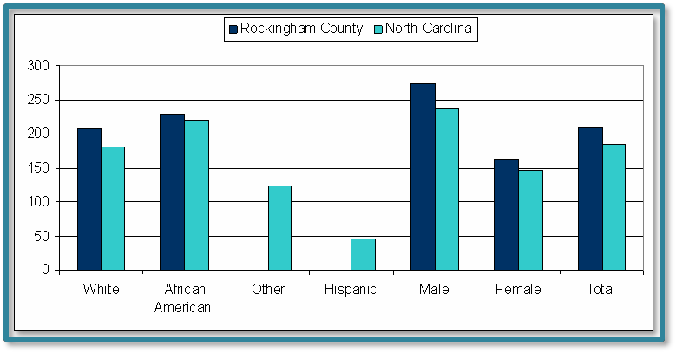

Race/Ethnicity-Specific and Sex-Specific Age-Adjusted Cerebrovascular Disease Death Rates for Rockingham County Compared to North Carolina, 2006 – 2010
(per 100,000)
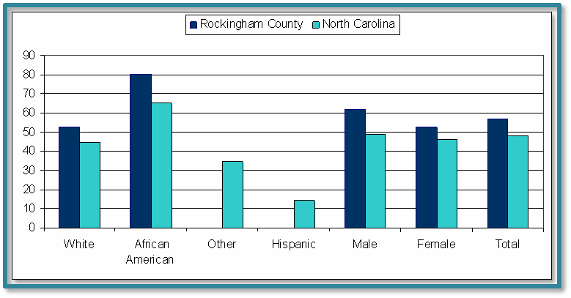
Cancer
In 2010, Rockingham County had approximately 227 cancer deaths, resulting in a death rate of
242.4. This was higher than North Carolina’s death rate of 188.9 and significantly higher than Healthy North Carolina’s 2010 health objective of 166.6 per 100,000. The 2012 Community Assessment Survey showed that 33% of survey respondents said that cancer was their top health concern in the county; out of the available choices, this was the highest health concern for residents.

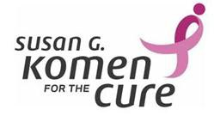North Carolina, 2010 Cancer Deaths by Site
Rockingham County, 2010 Cancer Deaths by Site

gress Notes

Prostate 4%

Prostate
5%
Trachea, Bronchus & Lungs
Trachea,
Bronchus & Lungs 31%
33%

Other 46%
Other
48%

Diabetes

Ro

Diabetes is the seventh leading cause of death in the nation. In 2010, North Carolina ranked 13th highest for adult diabetes prevalence among all states in the U.S. The 2012 Community Assessment Survey revealed that 31% (the third highest concern) of the respondents said diabetes was one of the top concerns.

Percentage and Estimated Number of Adults with Diagnosed Diabetes by Age in Rockingham County, 2008
Age | Rate | Number
18-44 | 3.1% | 979
45-64 | 12.9% | 3,297
65+ | 21.1% | 2,946
Overall | 9.3% | 6,612

- Health Behaviors and Lifestyle

Ro
(They group some of the focus diseases under the behaviors section to show how the diseases are related to the behaviors)

Top 10 Health Behaviors Identified by the Community Assessment

Health Behavior |  | Frequency | Percent | Lower 95% Confidence Limit for Percent | Upper 95% Confidence Limit for Percent
Alcohol Abuse |  | 111 | 52.4964 | 46.8041 | 58.1886
Drug Abuse |  | 90 | 41.8375 | 35.2261 | 48.4490
Poor Eating Habits |  | 63 | 31.1456 | 24.8349 | 37.4564
Lack of Exercise |  | 60 | 29.6612 | 19.9603 | 39.3621
Tobacco Use |  | 63 | 28.5004 | 21.8940 | 35.1068
Drinking and Driving |  | 49 | 23.2496 | 18.0652 | 28.4340
Not Getting Doctor Checkups |  | 43 | 20.1373 | 16.9940 | 23.2806
Child Abuse |  | 25 | 12.9995 | 8.2544 | 17.7445
Domestic Violence |  | 26 | 11.9373 | 7.1554 | 16.7192
Unsafe Sex |  | 25 | 11.3263 | 7.2810 | 15.3715

Tobacco Use

Ro
Tobacco use in Rockingham County remains a serious problem. The percentage of adult smokers in Rockingham County is far greater than the percentage in North Carolina and peer counties. In 2012, 31% of the adult population in Rockingham County reported smoking every day or “most days,” and have smoked at least 100 cigarettes in their lifetime, compared to 22% in North Carolina.

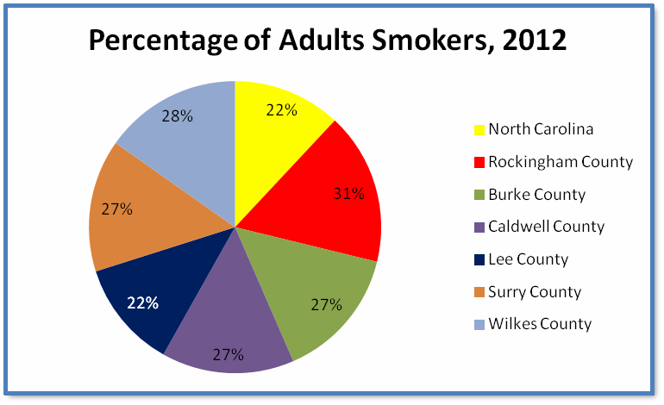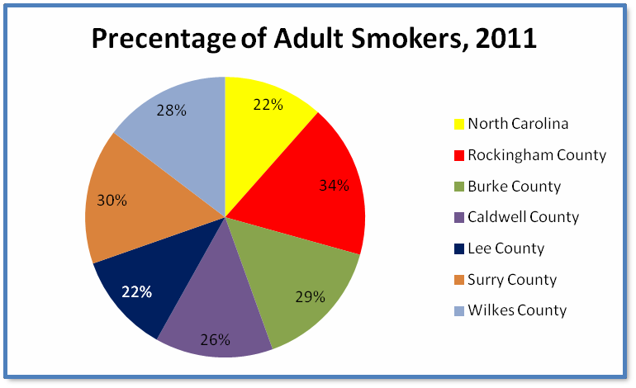

Violence

The rates for rape, robbery, and aggravated assault in Rockingham County decreased from 2009 to 2010. Aggravated assault saw the greatest decrease, going from 83 assaults in 2009 to 62 in 2010.


Rockingham County Violent Crime Statistics, 2009 - 2010
350.0
300.0
250.0
200.0
150.0
100.0
309.7
243.8
2009
74.2
2010
63.1
50.0
0.0
2.2 3.3
16.4
8.7
Murder
Rape
Robbery
Aggravated
Assault

Ro

Nutrition and Physical Activity

Obesity--Two-thirds of adults and nearly one-third of children and teens in the United States are currently obese or overweight. Fifteen years ago, North Carolina had an obesity rate of 16.3% and was ranked the 12th most obese state in the nation. Now, fifteen years later, North Carolina has an obesity rate of 30% and is ranked the 14th most obese state in the nation. Rockingham County has the highest obesity rate among its peer counties.

Obesity Percentages for Rockingham County Compared to Those of the State and Peer Counties
Location |  | % Obesity Population
 | 2010 | 2011 | 2012
North Carolina | 29% | 29% | 29%
Rockingham County | 31% | 31% | 33%
Burke County | 28% | 27% | 28%
Caldwell County | 30% | 31% | 30%
Lee County | 29% | 29% | 30%
Surry County | 28% | 28% | 31%
Wilkes County | 28% | 29% | 30%

Exercise--Of the residents of the Piedmont Region of North Carolina (which includes Rockingham County), 46.3% meet the physical activity recommendations set by the state, whereas 12.2% are physically inactive. According to the 2012 Community Assessment Survey, 22% of residents in Rockingham County do not engage in any physical activity/exercise for at least half an hour on a weekly basis. The lack of physical activity and proper nutrition contributes to 33% of children ages 12 to 18 being overweight.

Ro

 | Meet Recommendations | Some Physical Activity | Physically Inactive
Piedmont Region (Includes Rockingham County) | 46.3% | 41.5% | 12.2%
North Carolina | 46.4% | 40.4% | 13.2%

ight 5th
Prevalence of Overweight, At-Risk for Overweight, Normal, and Underweight Children through BMI by Age in Rockingham County Compared with North Carolina, 2009
Age 12  through 18 | Underweight (<5th Percentile)
 | # | % | # % # |  | % # |  |  | %
Rockingham County | 0 | 0.0 | 47 47.5 17 |  | 17.2 35 |  |  | 35.4 | 99
North Carolina | 133 | 1.9 | 3,560 51.9 1,241 |  | 18.1 1,920 |  |  | 28.0 | 6,854

ntile) Total

Diet--When it comes to eating the recommended five or more fruits and vegetables per day, only 21.2% of residents consume the recommended daily amount. In Rockingham, 44% of residents who participated in the Community Assessment Survey do not consume the recommended amount of fruits and vegetables daily.

 | NO | YES
Piedmont Region (Includes Rockingham County) | 78.8% | 21.2%
North Carolina | 79.4% | 20.6%

Maternal and Child Health
Infant Mortality
In 2003, the infant death rate for Rockingham County was 9.1 per 1,000 live births. In 2010, the infant death rate for Rockingham County decreased to 7.4 per 1,000 live births, only slightly higher than North Carolina’s 2010 infant death rate of 7.0 per 1,000 infant deaths. The Healthy North Carolina objective is to reach a mortality rate of 1.92 by the year 2020. 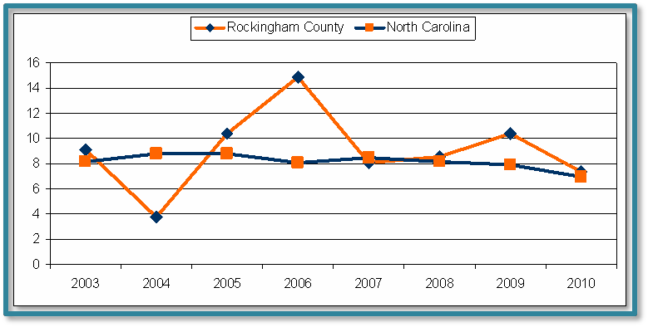

Infant (<1 year) Death Rate Trends for Rockingham County and North Carolina, 2003-2010 (per 1,000 live births)

Ro
Teenage Pregnancy

In 2010, North Carolina’s teen pregnancy rate dropped the lowest in history, 49.7 per 1,000 15 to 19- year-old females. Rockingham County’s rate also fell in 2010 to 58.3 per 1,000, but is still considerably higher than that of the state. In Rockingham County and North Carolina, Hispanic women ages 15-19 experience higher pregnancy rates than any other ethnicity.

Teen (Ages 15 to 19) Pregnancy Rates for Rockingham County Compared to North Carolina, 2010 (per 1,000)

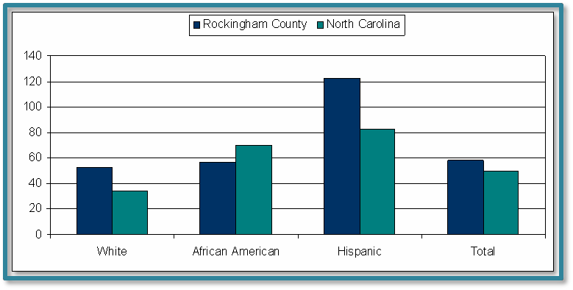

Smoking While Pregnant

Ro
From 1994 to 2008, the percentage of women who smoked while pregnant decreased in Rockingham County (20.7%), but was still significantly higher than North Carolina (11.5%) and remarkably higher than Healthy North Carolina’s 2020 objective of 6.8%.

Percentages of Resident Live Births Where Mother Smoked During Pregnancy in Rockingham County, 1994-2008

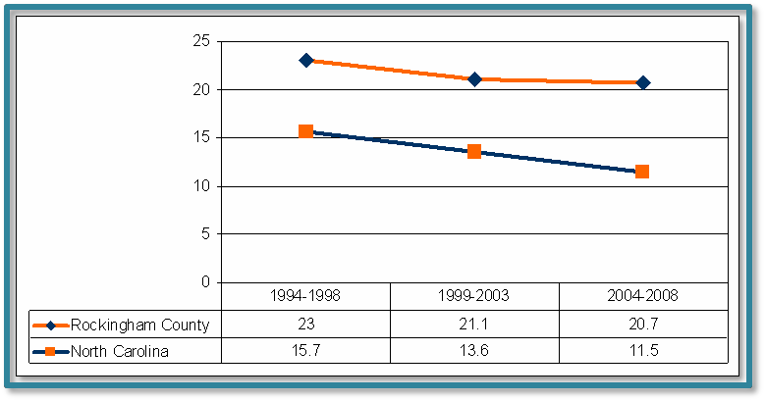

Unintentional Injury

Motor Vehicle Traffic crashes (MVT) were the leading cause of injury death in Rockingham County, at 76 deaths from 2007-2009, followed by unintentional falls, for both leading cause of injury hospitalizations and ED visits, at 1,317 and 6,069, respectively.

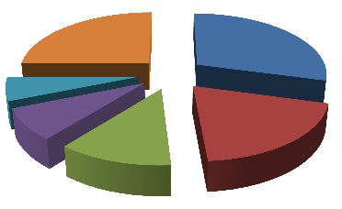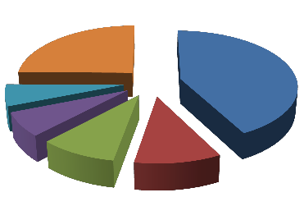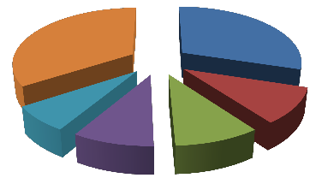
Rockingham County Leading Causes
of Injury Hospitalizations, All Ages, 2007-2009
Fall, Unintentional
770
1317
193
215
290
323
MVT, Unintentional
Poisoning, Self-inflicted Poisoning, Unintentional Unspecified, Unintentional
Other
Rockingham County Leading Causes
of Injury ED Visits, All Ages, 2007-2009
Fall, Unintentional
Rockingham County Leading Causes
of Injury Death, All Ages, 2007-2009
MVT, Unintentional
6969
6069
1450
1850
2042
Struck, Unintentional
Unspecified, Unintentional MVT, Unintentional Overexertion, Unintentional
Other
65
76
16
21
1949
31
51
Poisoning, Unintentional
Fall, Unintentional Firearm, Self-inflicted Unspecified, Unintentional Other

Recommendations

(this report is lacking a specific Recommendations section)

8. Sources of Information--State and Local Statistics

Secondary data was collected through a variety of sources. Secondary data is also available in the Rockingham County Data Book found on the department’s website, www.rockinghamcountypublichealth.org. An aggregate report was developed from Rockingham County’s priority health issues, priority health populations, and community resources. Once all the data was collected, a comprehensive list of top health concerns was created, and community stakeholders came together to select the top three priority health issues.

Ro

Ro

Become Pro-Active!
Join the Rockingham County Healthy Carolinians Partnership! Healthy Carolinians needs community participation to find creative solutions so that all Rockingham County residents can choose health as their priority. For more information, please call the Healthy Carolinians Coordinator at 336-342-8258.

